QM Assessment Tool

- This tool should perform a series of quick calculations based on data entered by the user or collected from the LOS.
- The data collected should be assessed in a series of 3 to 4 simple calculations for a final result – pass or fail.
- Based on the result of pass or fail, the tool should return a final recommendation along with the identified analysis of the file.
- If a file fails the analysis the tool should provide a button to automatically send the order to the back up title vendor.
- If the file passes the analysis the tool should return the pass result and offer to send the order to the affiliate.

Data needed:

- First Name
- Last Name
- Borrower First Name
- Borrower Last Name
- Company Name
- Relationship (drop down)
  - Manager
  - Loan Officer
  - Broker
  - Realtor
  - Processor
  - Builder
- Email Address
- Phone
- Property Address (Street, Zip., City, State)
- Transaction Type (drop down)
  - Refinance
  - Purchase
  - Reverse
- Loan Type (check all that apply)
  - FHA
  - VA
  - Conventional
  - Equity
  - Equity Line of Credit
  - Cash Out
  - Construction
- Property Type (check all that apply)
  - Single Family
  - Condo
  - Investment
  - Manufactured Housing
  - Unimproved Land
- Interest Type (drop down)
  - Fixed
  - Variable Rate
  - Variable Rate, Negative Am
- Loan Amount
- Prior lender policy Date
- Prior lender policy Amount
- Unpaid Balance of prior borrower’s loan (refinance or purchase)
- Prior owner policy date
- prior owner policy amount
- Unpaid balance of loan if seller for purchase reissue calculation only
- Select required endorsements (ALTA 4,5,6,7,8, or 9)
  - Planned Unit Development
  - Survey coverage
  - Condo
  - Variable Rate Endorsement
  - Variable Rate, Negative Am
  - Manufactured Housing
  - Environmental Protection (automatically select this one)
  - Restrictions, Encroachments, Minerals (Automatically select this one)
- Total Settlement Fee applied by Affiliate
- Appraisal Fee if Affiliated
- Credit Fee if Affiliated
- Third Party Origination Fee
- Lenders Fees Total
- Survey Fee if Affiliated
- Notary Fee if affiliated
- Inspection fees if affiliated

CAPS for calculation.
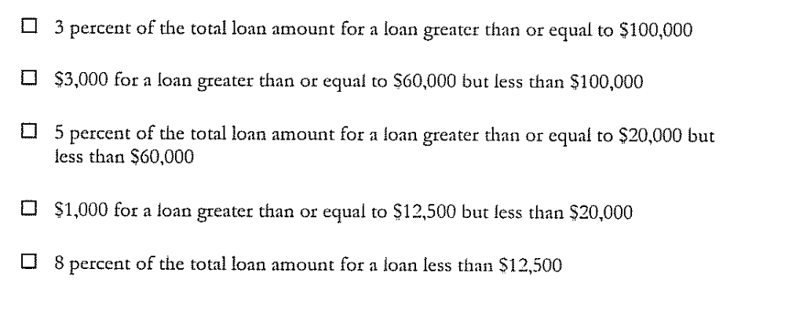

Calculations:

Data collection screen 1:

Is title affiliated?
If Yes, What is the total of their settlement fees?
(We will calculate the premium in a moment.)

Is appraisal affiliated?
If yes, what is the appraisal fee?

Is Credit affiliated?
If Yes what is the appraisal fee?

Is the loan originator a direct employee of the lender?
If no, what is the total mortgage originator compensation amount?

Is Survey Affiliated?
If yes, what is the survey fee?

Is Credit affiliated?
If yes, what is the credit fee?

Is notary affiliated?
If yes, what is the notary fee?

Is Inspection Affiliated?
If yes, what is the inspection fee?

Calculation 1:

Total of all affiliated fees. Show on screen.
Run quick cap calculation here to see if we need to continue the analysis. If the fees are already over the cap, display fail result here and offer to reassign to back up provider now. If passing show how much is left in the cap.

PASS PRIOR TO TITLE PREMIUM CALCULATION: $0000.00 remaining in CAP
FAIL PRIOR TO TITLE PREMIUM CAP. SEND TO BACK UP PROVIDER NOW. (Button)

We have identified so far that your cap allowance has $0000.00 remaining. Please enter as much data as possible for us to calculate the best title insurance premium result for you to send to your affiliate if caps can be maintained.

Data collection 2.
Enter prior policy data and unpaid balance for buyer and seller where known.

Buyer/Borrower:
Prior policy date
Prior policy amount
Unpaid balance
Is prior policy available as proof of prior?

Seller:
Prior policy Date
Prior policy amount
Unpaid Balance
Is prior policy available as proof of prior?

Pull unique questions (do not pull streamlined rates).

- Calculate the title premium (Basic Rate or reissue) with unique discounts applied.
- Add to prior calculation of total fees collected against the cap from prior screen.
- Compare the new total with the title insurance premium against the cap.
- Return Pass/Fail Result.

This transaction has PASSED/FAILED the initial QM analysis based on your data input.
PASSED Button to send to affiliate with data results and premium calculation.
FAILED Button to send to Madison Settlement Services

Email QM Analysis report to this email address: Input email address here by user.
Button to email report.

Upload 1003 for order placement or title order document.

